**CarSales Summary (based on sales Oct 4-11, 2019 – this data is from our original pull, all subsequent pulls may result in different data)**

Graph/Plot 1

* Top 5 auto manufacturers by sales in Georgia:
  + 1. Toyota 2. Chevrolet 3. Ford 4. Jeep 5. Honda
* Sales in the preceding 7 days:
  + Toyota – 2,678 Chevrolet – 2,460 Ford – 2,195 Jeep – 1,212 Honda – 897
* Total count of Top 5 makes sold 9,442
* Percentage breakdown of Top 5 models:
  + Toyota – 28% Chevrolet – 26% Ford – 23% Jeep – 13% Honda – 10%

Graph/Plot 2

* Top 5 auto models by sales in Georgia
  + 1. F-150 2. Silverado 3. Camry 4. 1500 5. Corolla
* Sales in the preceding 7 days:
  + F-150 – 1,134 Silverado – 799 Camry – 652 1500 – 601 Corolla – 532
* Total count of Top 5 models sold 3,718
* Percentage breakdown of Top 5 models:
  + F-150 – 31% Silverado – 21% Camry – 18% 1500 – 16% Corolla – 14%

Graph/Plot 3

* Top 5 auto manufacturers by sales in US
  + 1. Chevrolet 2. Ford 3. Toyota 4. Honda 5. Jeep
* Sales in the preceding 7 days:
  + Chevrolet – 87,145 Ford – 84,529 Toyota – 81,227 Honda – 54,367 Jeep – 43,220
* Total count of Top 5 models sold 350,488
* Percentage breakdown of Top 5 models:
  + F-150 – 31% Silverado – 21% Camry – 18% 1500 – 16% Corolla – 14%

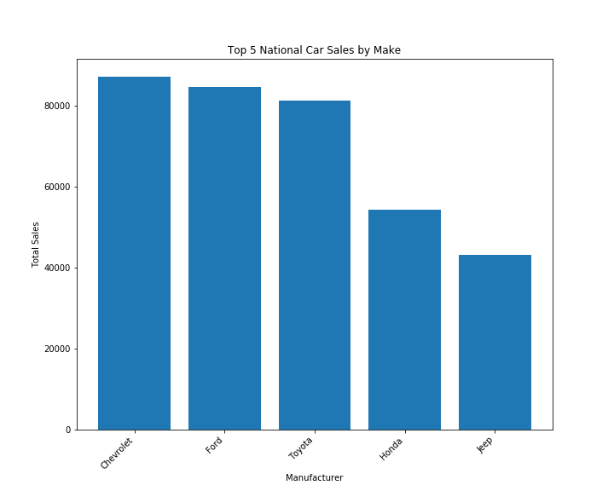

Graph/Plot 4

* Top 5 auto models by sales in Georgia
  + 1. F-150 2. Silverado 3. 1500 4. RAV4 5. CR-V
* Sales in the preceding 7 days:
  + F-150 – 36,399 Silverado – 24,821 1500 – 21,355 RAV4 – 18,253 CR-V – 15,759
* Total count of Top 5 models sold 116,587
* Percentage breakdown of Top 5 models:
  + F-150 – 22% Silverado – 21% 1500 – 18% RAV4 – 16% CR-V – 14%

